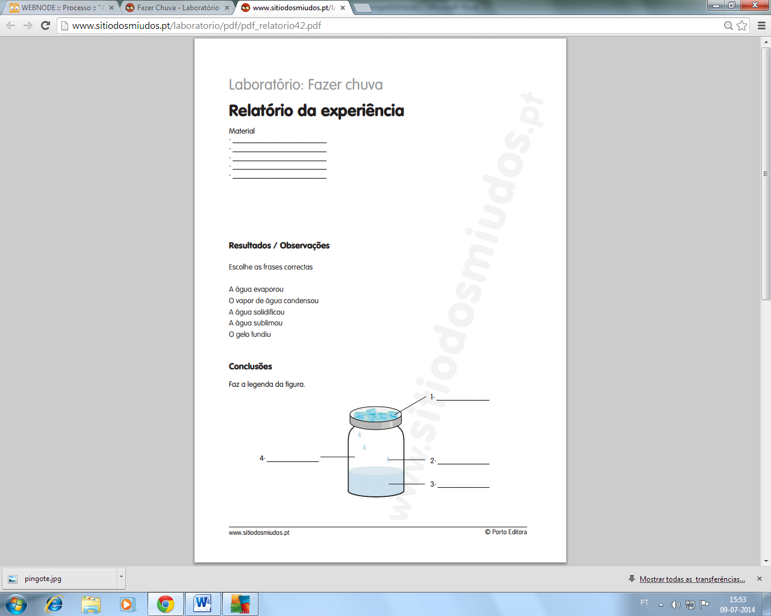

Nome: ___________________________________________________

Data: ___________